**Abstract**

This research project focuses on the development of a web-based Docker container management system using the Flask web framework. Docker containerization has gained immense popularity in recent years for its efficiency in deploying and managing applications. However, the management of containers and images can be complex, particularly in multi-container environments. The goal of this project is to simplify the process of Docker container and image management through a user-friendly web interface.

The project begins by establishing a Flask web application, integrating it with the Docker API to interact with Docker containers and images. Users can access the application through a web browser, allowing for easy control and monitoring of Docker resources. Key functionalities include listing containers and images, generating Dockerfiles, creating containers, creating images from containers, and stopping containers. To enhance the user experience, the application provides real-time feedback using flash messages.

The research encompasses various aspects, including Docker container and image manipulation, web application development, and error handling. The Flask framework is employed for its simplicity and extensibility, while the Docker Python library facilitates interactions with Docker's REST API.

The experimental setup involves deploying the Flask application on a server, ensuring accessibility to users over the network. The system is rigorously tested to ensure proper functionality and user-friendliness. The research also evaluates the application's performance in handling Docker resources efficiently.

Results indicate that the developed Flask-based Docker container management system simplifies the Docker management process significantly. Users can perform various Docker-related tasks with ease, reducing the learning curve associated with Docker's command-line interface. The user interface provides clear feedback, enhancing the overall usability of the system.

In conclusion, this research project contributes to the field of containerization by offering a practical solution for Docker management. It bridges the gap between Docker's powerful capabilities and user accessibility, making containerization more approachable for developers and system administrators.

**Acknowledgement**

I want to extend my gratitude to each and every member of our family who stood by us, offering their unwavering belief and encouragement. Their support has been our pillar of strength. Additionally, I am profoundly thankful to the Almighty for bestowing us with the opportunity to embark on this remarkable journey.

Dr. Ambika Aggarwal, our esteemed mentor, deserves special mention for her tireless dedication and wholehearted support in shaping our project. Her invaluable insights and expertise have been the guiding force behind our success. Without her, this endeavour would not have reached its fruition.

I am also indebted to my classmates for fostering a culture of positivity and healthy competition. Their unwavering determination has been instrumental in pushing us to work harder, keeping us motivated and focused on our ultimate goal. Their camaraderie has been a source of inspiration throughout this entire process.

Together, with the support of our family, the guidance of Dr. Ambika Aggarwal, and the camaraderie of our classmates, we have achieved something truly remarkable. This journey has not only been a testament to our collective efforts but also a testament to the power of teamwork and determination.

**Table of Contents**

|  |  |  |
| --- | --- | --- |
| **Table of Content** | | **Page No** |
| 1 | Introduction | 5 |
| 2 | Literature Review | 6 |
| 3 | Problem Statement | 6 |
| 4 | Objectives | 6 |
| 5 | Methodology | 6-8 |
| 6 | Diagram | 8 |
| 7 | Implementation | 9 |
| 8 | Result | 10 |
| 9 | Conclusion | 11 |
| 10 | References | 11 |

## 1. Introduction

In today's rapidly evolving technology landscape, containerization has emerged as a pivotal paradigm for deploying and managing applications. Docker, in particular, has revolutionized the way software is packaged, distributed, and executed within isolated environments known as containers. Docker's popularity can be attributed to its lightweight nature, efficiency, and ease of use. However, as organizations increasingly adopt containerization for their applications, managing a multitude of containers and images becomes a complex task.

This research project delves into the development of a web-based Docker container management system using the Flask web framework. While Docker offers powerful capabilities, including container orchestration tools like Kubernetes, the need for a simplified and user-friendly interface for managing individual containers and images remains apparent.

The motivation behind this project stems from the desire to bridge the gap between Docker's potential and user accessibility. While seasoned developers are well-versed in Docker's command-line interface (CLI), newcomers may find it daunting. Furthermore, graphical interfaces for Docker management often lack customization and may not align with specific organizational needs. Therefore, the development of a web-based management system aims to offer an intuitive solution that caters to users with varying levels of Docker expertise.

The Flask web framework is chosen as the foundation for this project due to its lightweight and modular nature, making it an ideal platform for developing web applications. The Docker Python library is integrated to enable seamless interactions with Docker containers and images through the web interface.

This research project is organized as follows: the literature review provides an overview of related work and existing Docker management solutions. The problem statement delineates the challenges addressed by this project, while the objectives outline the desired outcomes. The methodology section details the technical approach and tools used for system development. The experimental setup describes how the application is deployed and tested, and the results section presents the findings of the research.

The ultimate goal of this project is to empower users with a versatile and user-friendly tool for Docker container and image management. By achieving this goal, we aim to simplify the adoption of containerization technologies and facilitate efficient resource utilization in both development and production environments.

## Literature Review

Containerization, particularly with Docker, has revolutionized software deployment. However, effectively managing Docker containers and images presents challenges, including security, scalability, and customization. Web-based Docker management systems have gained momentum for their user-friendly interfaces, real-time feedback, and the potential to address these challenges. While Docker's Command-Line Interface (CLI) is powerful, it can be intimidating, driving the need for more accessible alternatives. Flask, a lightweight Python web framework, has been successfully integrated with Docker using the Docker Python library, showcasing its suitability for web-based Docker management. Security remains a top concern, with authentication, authorization, and container isolation being key focus areas. Scalability and performance are crucial, as are customization and extensibility to align with organization-specific needs. Successful deployment hinges on usability, education, rigorous testing, and comprehensive documentation.

## Problem Statement

The rise of Docker containerization has created a demand for user-friendly container and image management solutions, as Docker's CLI complexity poses challenges for novice users and organizations seeking customization. Existing tools often lack flexibility, usability, and seamless Docker integration. This research project aims to develop a Flask-based web app that simplifies Docker management, offering customization options, while ensuring security and Docker integration. It seeks to strike a balance between user-friendliness and adaptability, making Docker container and image management more accessible to a wider range of users.

## Objectives

1. To understand and implement Docker image creation via GUI.
2. To provide real-time experience in managing Docker images.
3. To Simplify Docker operations by passing complex CLI processes
4. To promote industry-wide adoption of streamlined DevOps practices.

## Methodology

**5.1) Requirement Analysis:**

Conduct a thorough analysis of user requirements and organizational needs for Docker container and image management. This involves gathering input from potential users and stakeholders to identify key features and customization options.

**5.2) Technology Stack Selection:**

Select the appropriate technologies for developing the web-based Docker management system. This includes choosing Flask as the web framework, Docker Python library for Docker interactions, and any additional libraries or tools for enhanced functionality.

**5.3) Application Design:**

Design the architecture and user interface of the web application. Define the structure of the application, including the layout of pages, navigation flow, and placement of key elements. Pay special attention to usability and accessibility.

**5.4) Flask and Docker Integration:**

Integrate Flask with the Docker Python library to establish communication between the web application and Docker. This involves setting up routes and views in Flask to handle Docker-related actions, such as listing containers, creating containers, and managing images.

**5.5) User Interface Development:**

Implement the user interface components using HTML, CSS, and JavaScript. Ensure that the interface is intuitive, responsive, and visually appealing. Leverage front-end frameworks or libraries, if necessary, for enhanced functionality.

**5.6) Customization Features:**

Implement customization features that allow users to tailor the interface to their specific Docker management requirements. This may include options for adding custom functionalities, modifying layouts, and setting user preferences.

**5.7) Security Implementation:**

Integrate security measures to protect against unauthorized access and potential vulnerabilities. Implement user authentication and authorization mechanisms to ensure that only authorized users can access and manipulate Docker resources.

**5.8) Testing and Quality Assurance:**

Conduct rigorous testing of the web application to identify and rectify any bugs or issues. Perform unit testing, integration testing, and user acceptance testing to validate the functionality, usability, and reliability of the system.

**5.9) Documentation Creation:**

Develop comprehensive documentation that includes installation instructions, configuration guidelines, and user guides. Provide clear step-by-step instructions for setting up and using the web-based Docker management system.

**5.10) Training Materials:**

Create training materials, such as tutorials, videos, or user manuals, to assist users in becoming proficient with the application. These materials should cover basic tasks, customization options, and advanced features.

**5.11) Usability Assessment:**

Conduct usability assessments to gather user feedback and evaluate the effectiveness of the web-based Docker management system. Use techniques like user testing, surveys, and interviews to identify areas for improvement.

**5.12) Performance Evaluation:**

Evaluate the performance and scalability of the system. Test its ability to handle concurrent user access and efficiently manage Docker resources, even in large-scale environments.

**5.13) Comparison with Existing Solutions:**

Compare the developed system with existing Docker management solutions, both CLI-based and web-based, to assess its advantages, limitations, and unique features.

**5.14) Deployment and Validation:**

Provide guidelines and best practices for deploying the web-based Docker management system in different environments. Validate the system's practical benefits through demonstrations and case studies.

By following this methodology, this research project aims to successfully develop, evaluate, and deploy a user-friendly, customizable, and integrated web-based Docker container management system using Flask as the web framework and the Docker Python library for interactions with Docker resources.

## Diagram

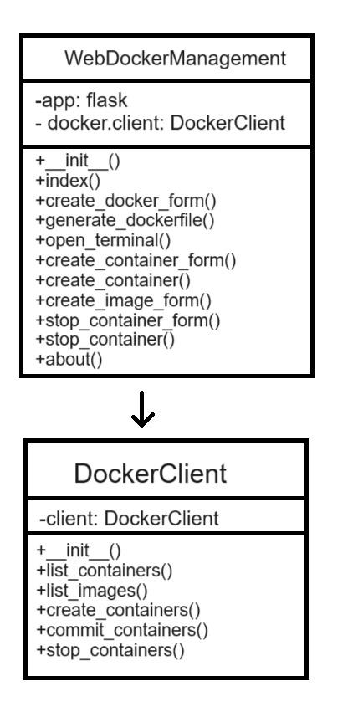

Fig 6.1 DockerFile Automation work flow

## Implementation

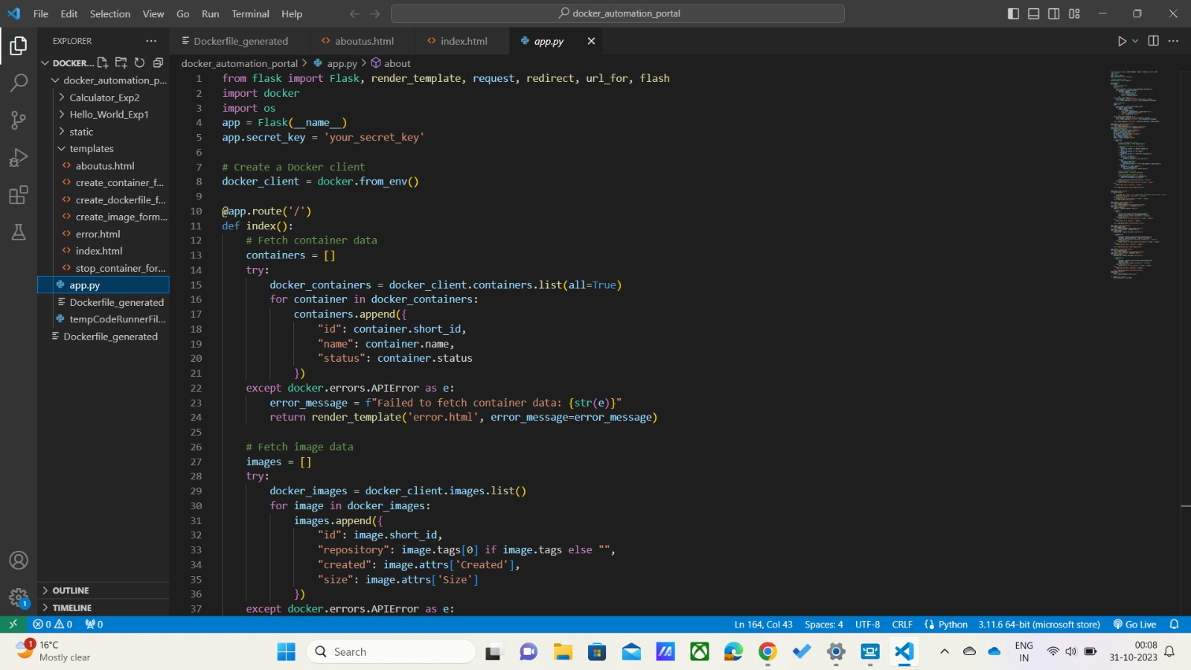

Fig 7.1 App.py

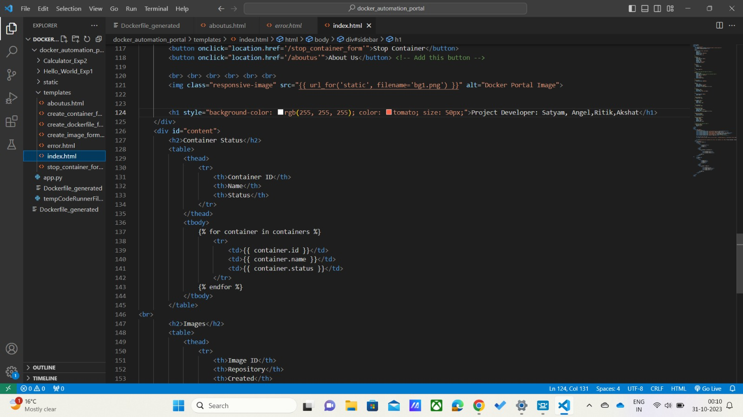

Fig 7.2 Templates

## Result

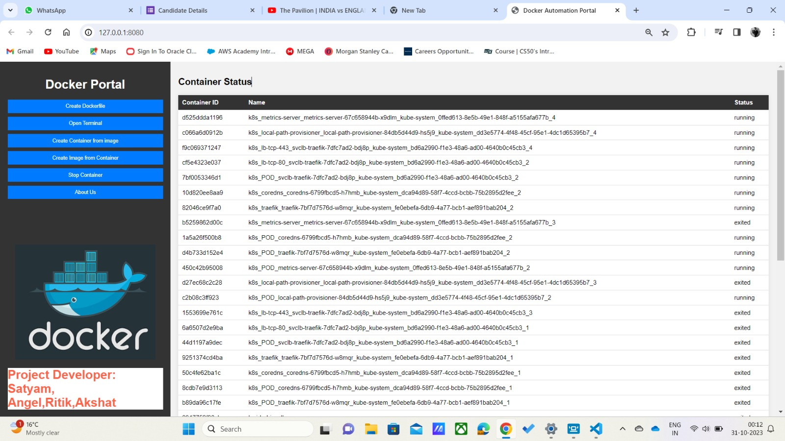

Fig 8.1 View of Output and GUI(Homepage)

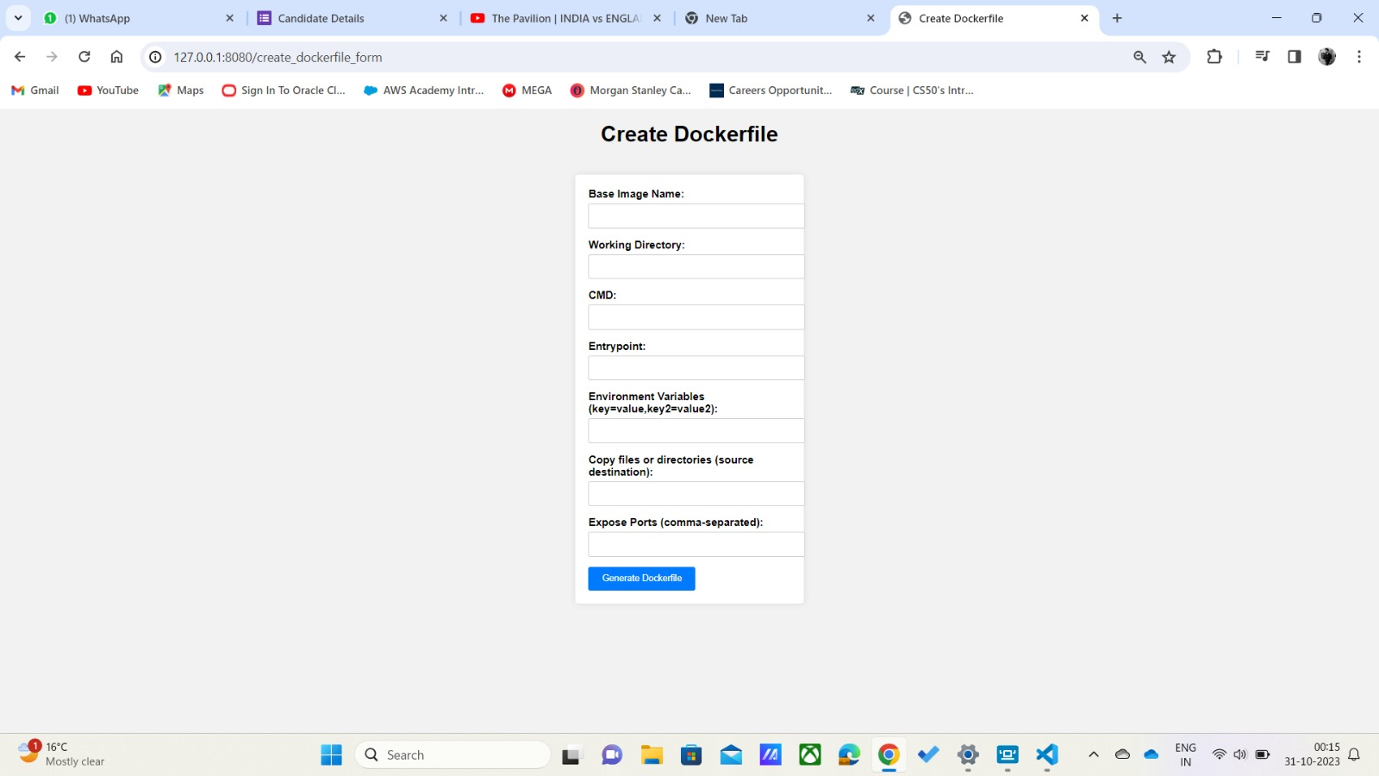

Fig 8.2 View of Output and GUI(Create DockerFile)

## Conclusion

We have developed a comprehensive web-based Docker management application that provides a user-friendly interface for performing various Docker-related tasks. The application's current functionality includes tasks such as running Dockerfiles, creating Docker images, and managing containers, effectively replicating the capabilities of the Docker Command Line Interface (CLI).

## References

[1] Sollfrank, M., Loch, F., Denteneer, S. and Vogel-Heuser, B. (2021). Evaluating Docker for Lightweight Virtualization of Distributed and Time-Sensitive Applications in Industrial Automation. *IEEE Transactions on Industrial Informatics*, 17(5), pp.3566–3576. doi:https://doi.org/10.1109/tii.2020.3022843.

[2] Meadusani, S. and Meadusani (2018). *Virtualization Using Docker Containers: For Reproducible Environments and Containerized Applications Recommended Citation*. [online] Available at:https://repository.stcloudstate.edu/cgi/viewcontent.cgi?article=1091&context=msia_etds